**Introduction to Databases**

**Week 4 Lab Work**

**Learning Goal** – Understanding entities, attributes & relationships

A DVD rental company has several branches throughout the country. The data held on each branch is the branch address made up of street, city, county, post code and telephone number. Each branch is given a branch number which is unique throughout the company. Each branch is allocated staff which includes a Manager. The Manager is responsible for the day-to-day running of a given branch. The data held on a member of staff is their staff id (which is unique), name, position and salary. Each branch has a stock of DVDs. The data held on each DVD is the catalog number (which is a unique number), DVD number (which represents the number of existing copies of that DVD), title and category and status (whether it is currently available to rent). Before borrowing a DVD from the company a person must first register as a member of a local branch. The data held on each member is first name, last name, address, registration date. Each member is given a unique membership number. The data held on each DVD rental is the rental number, the full name and membership number of the member, the DVD number, title and the dates the DVD is rented and returned.

**Tasks**

1. **Identify the entities**
2. **Identify the attributes and relationships**
3. **Entities:**

* **Branch.**
* **Staff.**
* **DVD.**
* **Member.**
* **Rental.**

1. **Attributes**

**Brach:**

* **Branch ID – primary key.**
* **Address (street, city, county, post code).**
* **Telephone number.**

**Staff:**

* **Staff id – primary key.**
* **Name.**
* **Position.**
* **Salary.**

**DVD:**

* **Catalog number - primary key.**
* **DVD number/quantity/copies.**
* **Title.**
* **Category.**
* **Status (Available).**

**MEMBER:**

* **Membership number – primary key.**
* **First name.**
* **Last name.**
* **Address.**
* **Registration date.**

**Rental:**

* **Rental number – primary key.**
* **Member first name.**
* **Member last name.**
* **Member membership number.**
* **DVD number.**
* **DVD Title.**
* **DVD rented date.**
* **DVD return date.**

**2.1) Relashionships**

**One branch has many staff.**

**Staff works in one branch.**

**Rental has one DVD and one Member**

**One branch has many dvd**

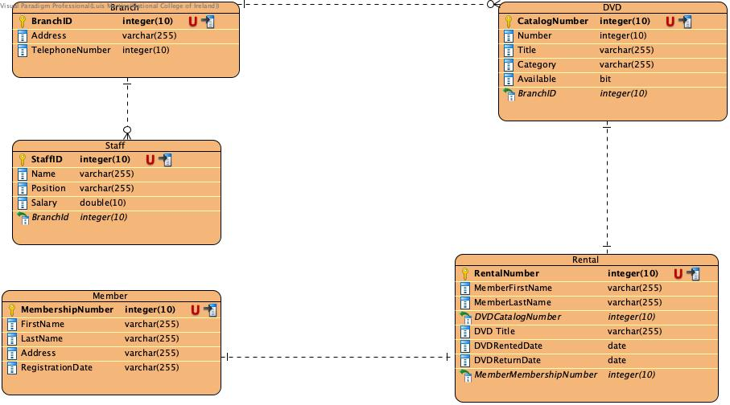

**I would also reference the member first name and last name but visual paradigm does not allow me to.**